**Day 41**

**Java Exception Propagation**

An exception is first thrown from the top of the stack and if it is not caught, it drops down the call stack to the previous method. If not caught there, the exception again drops down to the previous method, and so on until they are caught or until they reach the very bottom of the call stack. This is called exception propagation.

Exception can be handled in any method in call stack either in the main() method, p() method, n() method or m() method.

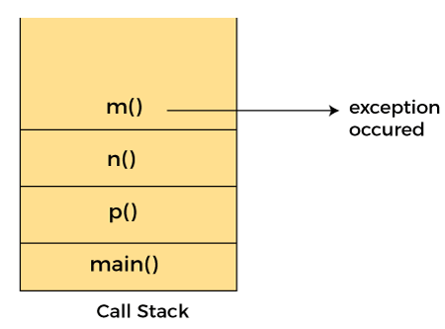

# Java throws keyword

The **Java throws keyword** is used to declare an exception. It gives an information to the programmer that there may occur an exception. So, it is better for the programmer to provide the exception handling code so that the normal flow of the program can be maintained.

Exception Handling is mainly used to handle the checked exceptions. If there occurs any unchecked exception such as NullPointerException, it is programmers' fault that he is not checking the code before it being used.

### Syntax of Java throws

1. return_type method_name() **throws** exception_class_name{
2. //method code
3. }

### Which exception should be declared?

**Ans:** Checked exception only, because:

* **unchecked exception:** under our control so we can correct our code.
* **error:** beyond our control. For example, we are unable to do anything if there occurs VirtualMachineError or StackOverflowError.

### Advantage of Java throws keyword

Now Checked Exception can be propagated (forwarded in call stack).

It provides information to the caller of the method about the exception.